Evidence Output

T014:

Valid address case.

Not input anything.

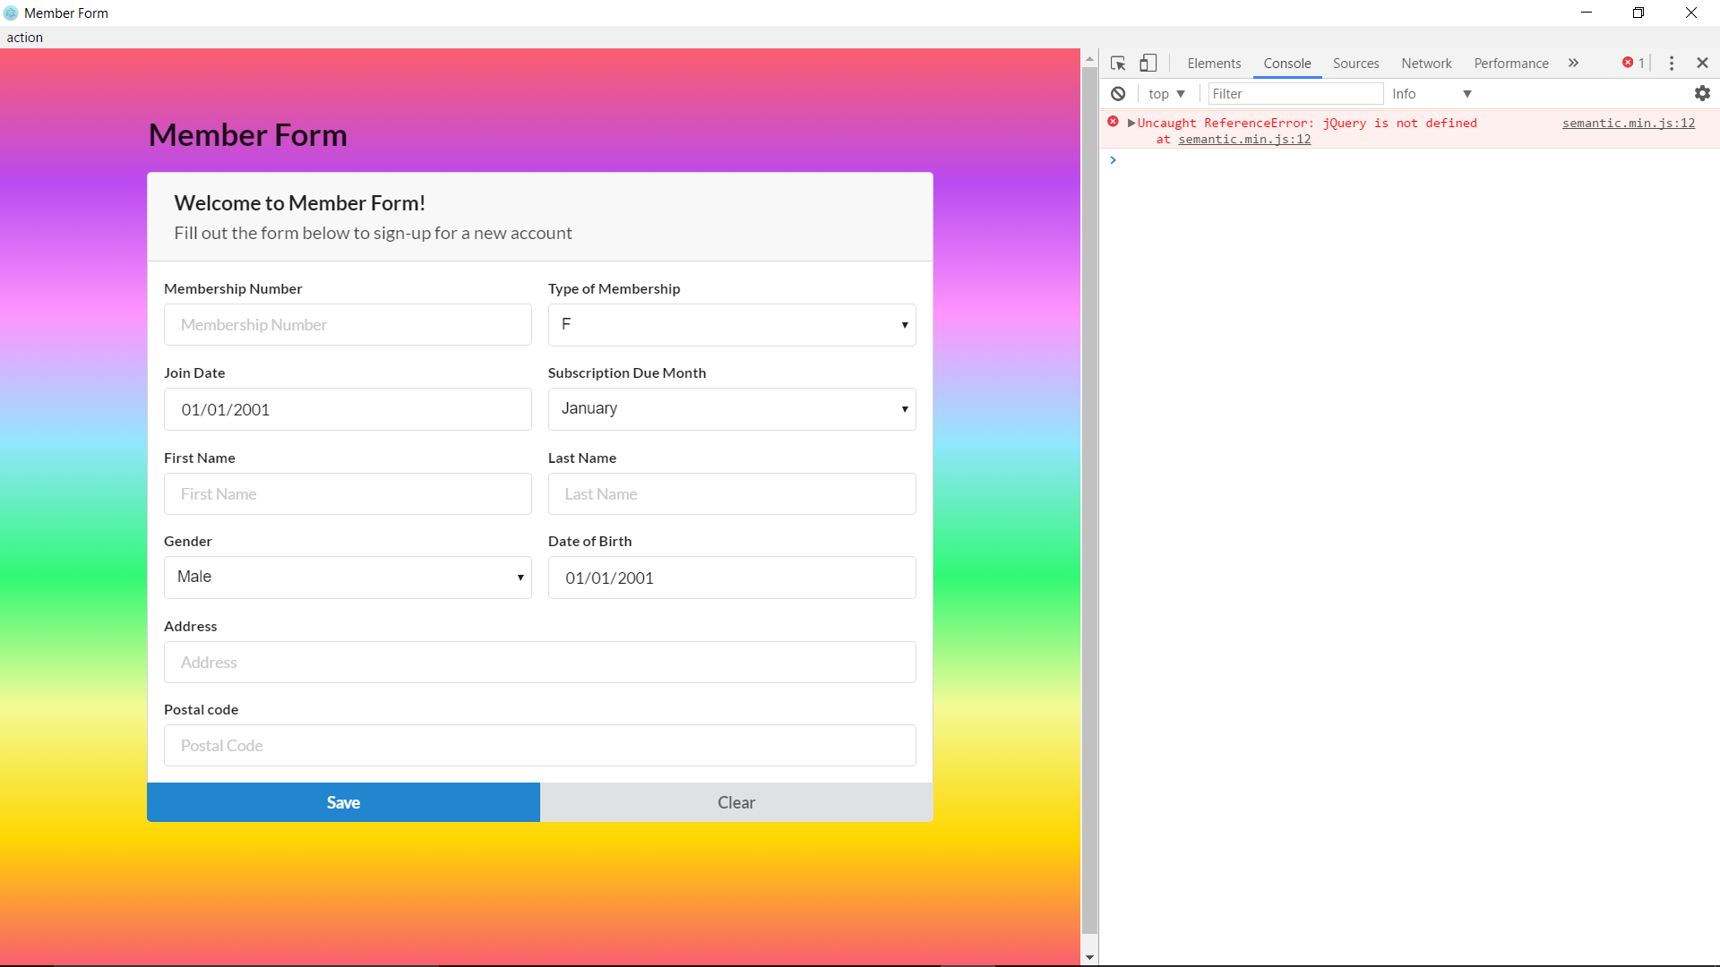

Valid last name case fail.

